## Predicting Optimal Channel for New Product Launch

## To identify the key drivers for predicting the preferred channel for our new product launch, it is essential to analyze various features present across multiple datasets.

## Univariate Analysis

### Units Sold of our product

Insights: The histogram shows a **right-skewed distribution**, indicating that while most values are on the lower end, there are a few significantly higher values (potential outliers).

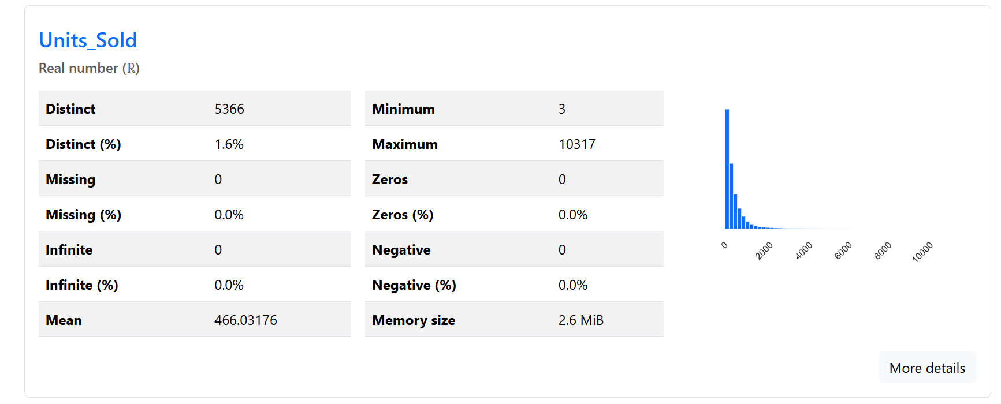

### Share of Voice across the competitor landscape

The histogram indicates a **bimodal distribution**, suggesting two distinct groupings in the data. This could reflect differences in marketing strategies, product categories, or regional variations.

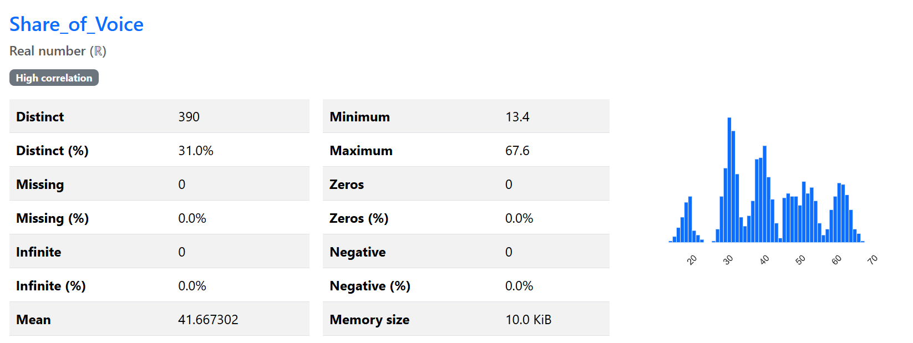

### Average Temperature across cities

This will help is predicting the seasonality of the product. As our product sales are high in summer season comparatively.

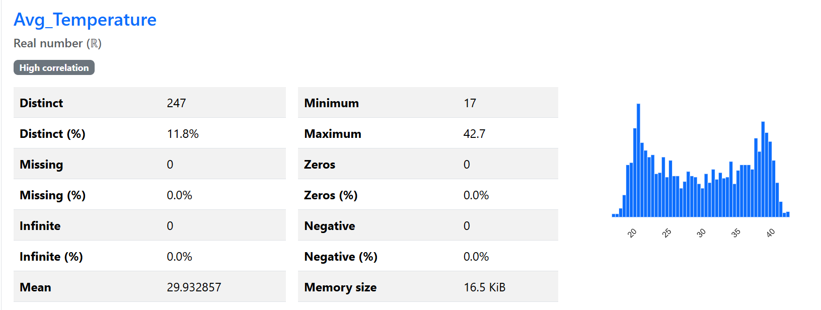

### Units Sold across Channels

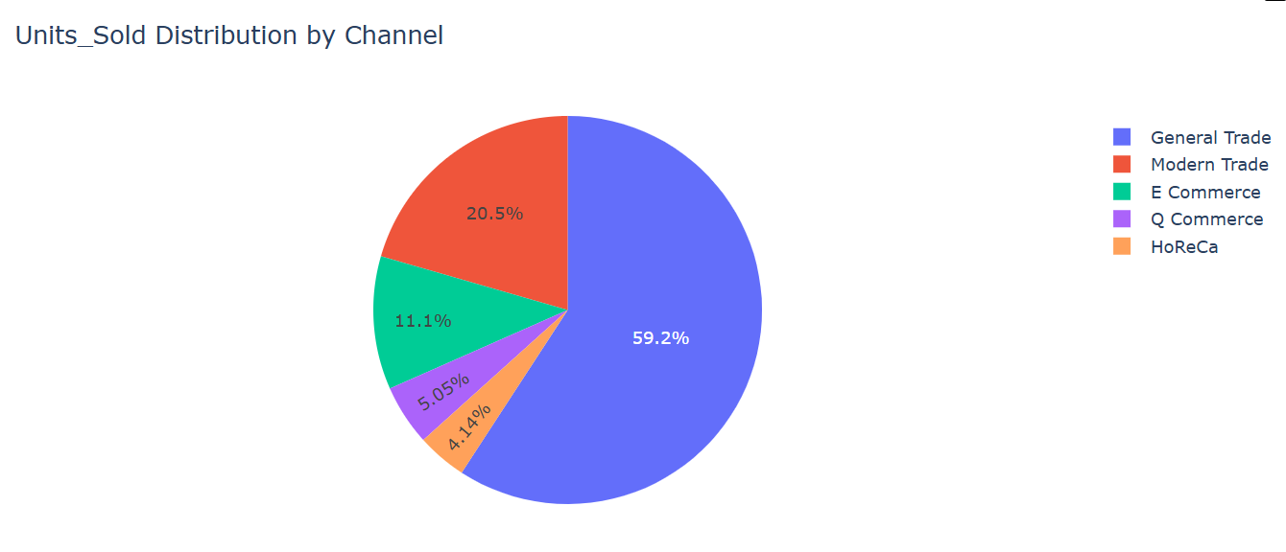

### SKU Sales

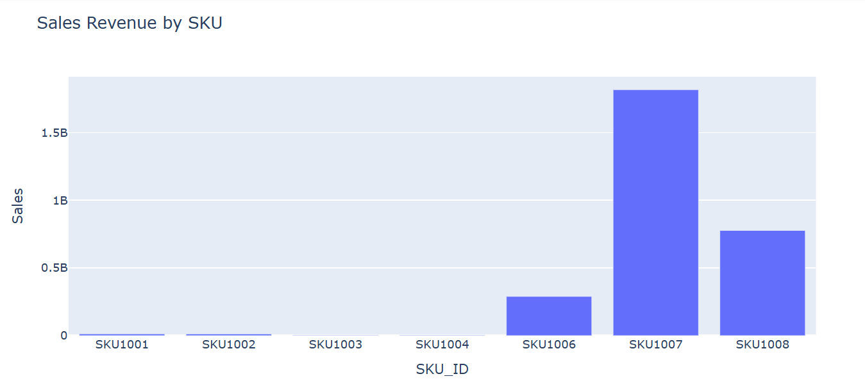

## Marketing Trends (Bivariate and Multivariate Analysis)

1. Seasonal Campaigns - The mentions fluctuate significantly, suggesting periodic spikes, likely due to marketing campaigns, product launches, or events.
2. Marketing Behavior & Seasonal Consumer Behavior - Many brands, such as Minute Maid, Real Fruit Juice, and Paper Boat, see spikes in mentions during summer months (June–July), which aligns with the seasonal demand for juices and beverages.
3. Minute Maid is leading the market, so we have a strong marketing presence.

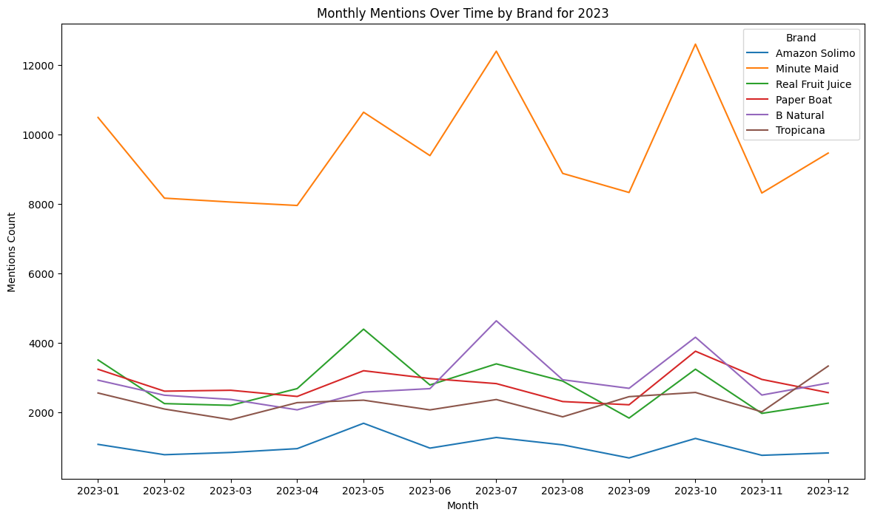

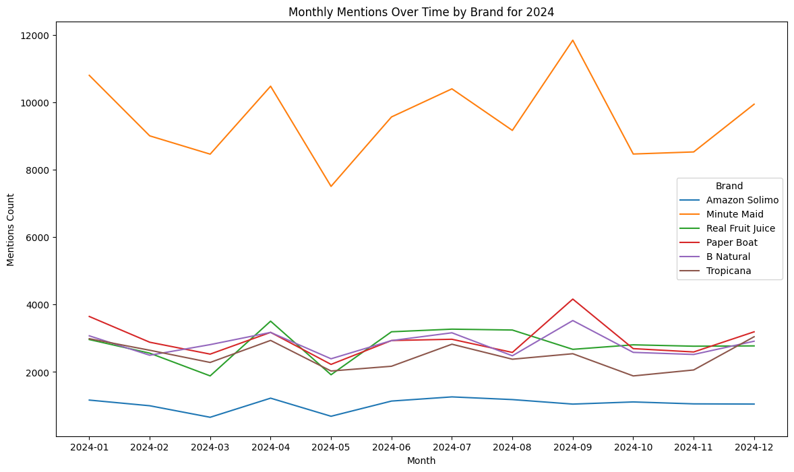

1. Also, our brand is having an overall positive image based on the sentiment scores.

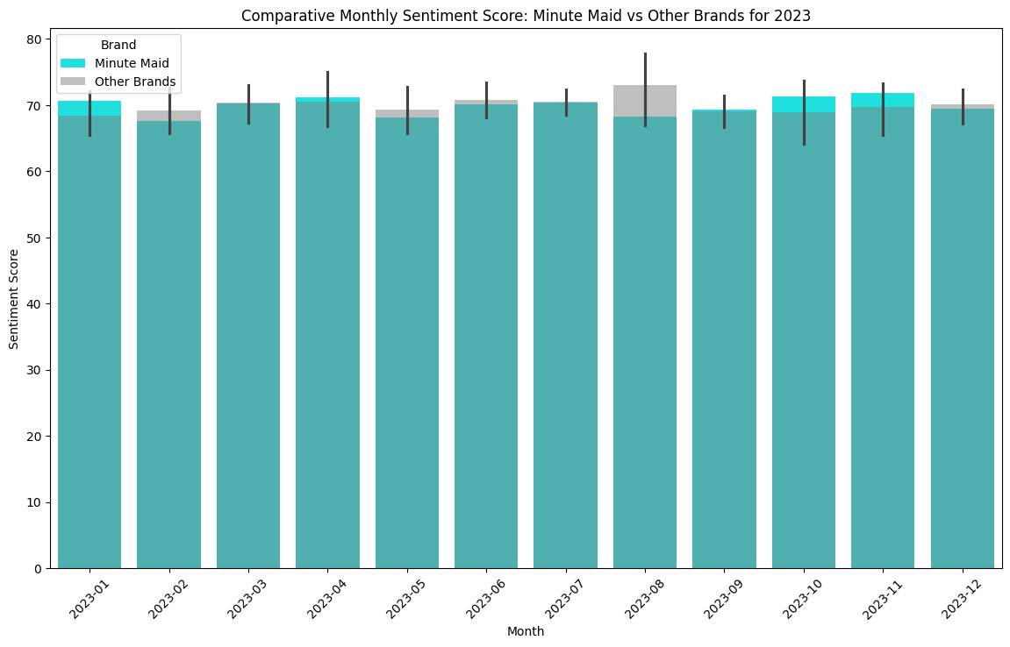

1. Our brand is present on all the channels, compared to other brands which have presence on utmost 2 channels.
2. The sentiment score is spread across equally on all channels for our brand, which will make it difficult to select the channel for launch of new product.
3. We will face less competition on "General trade", "Modern Trade" and "Q Commerce", as rest of the 2 channels ("HoReCa", "E Commerce") have presence on more than 1 competitor.

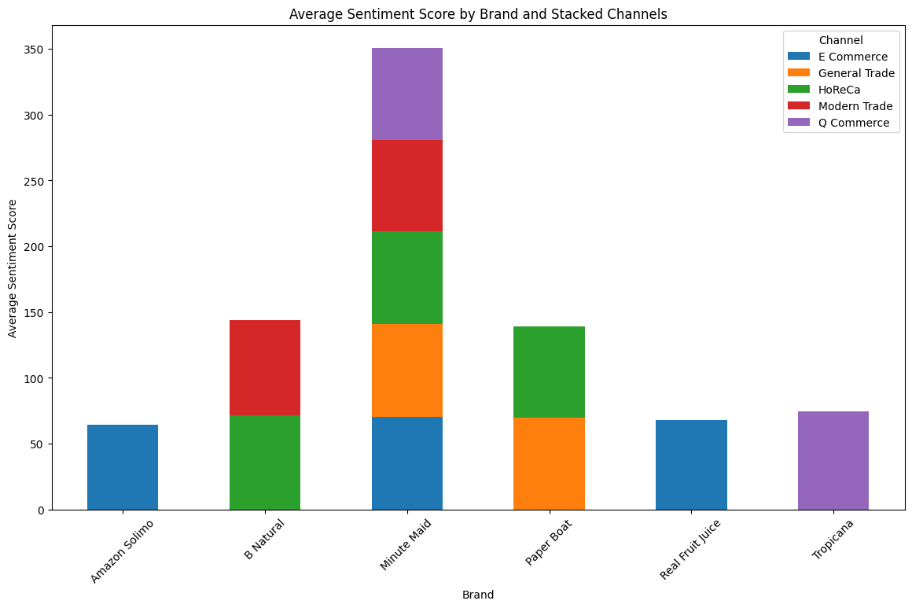

## Consumer Trends (Bivariate and Multivariate Analysis)

1. We have a varied consumer age-group and apple is the most preferred flavor across most of the age groups. Though, Orange is the most selling flavor from our Sales Trend.

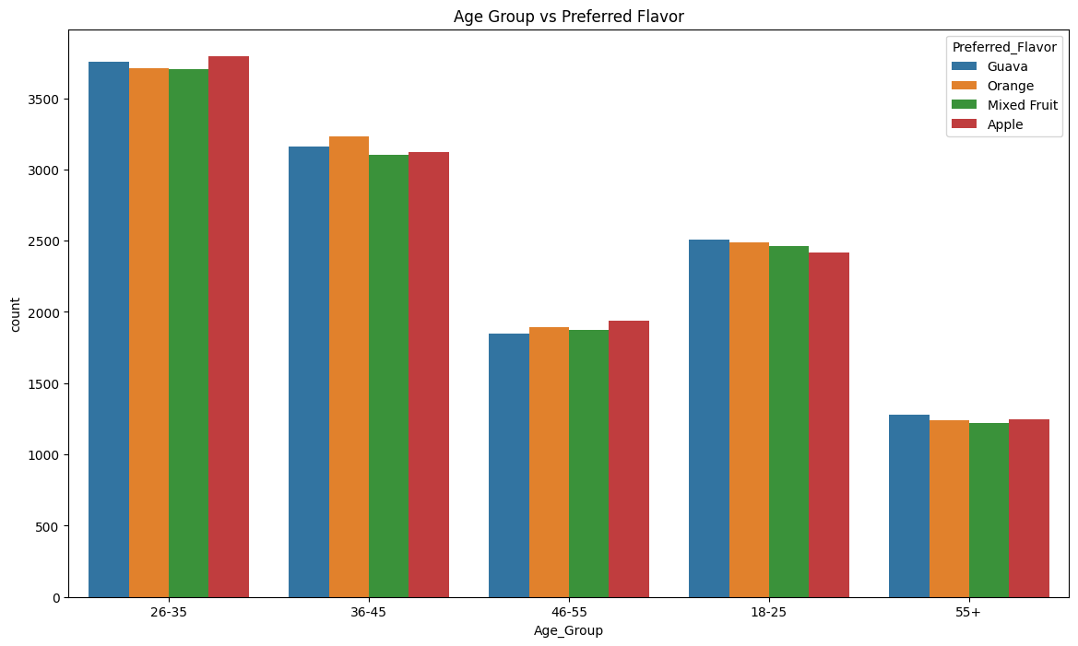

1. Interestingly, E-commerce is the most preferred channel, though the sales are highest for General trade.

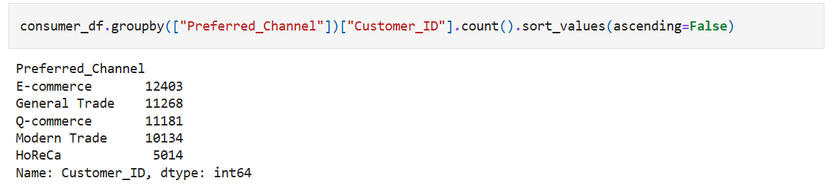

1. We have skewed dataset with the majority of individuals have relatively low income levels, while a smaller subset of individuals have significantly higher income levels.
2. The right-skewed nature of the distribution suggests economic disparity, where a large portion of the population earns less, and only a few individuals fall into the higher income brackets.

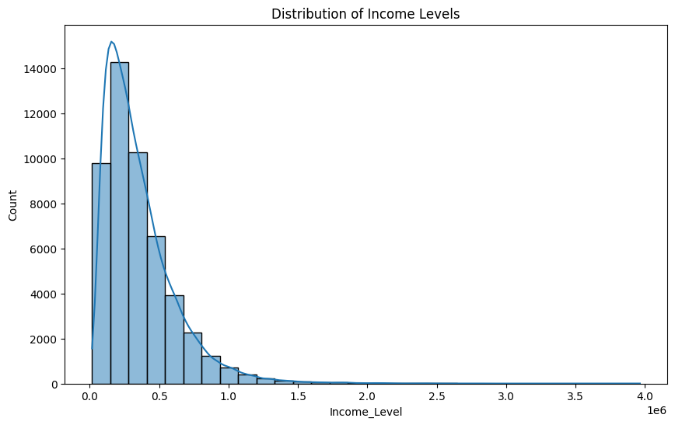

1. While looking at Preferred Channel and Purchase Frequency, we got to know that General Trade tends to have slightly higher purchase frequencies and a broader range of customer behavior.
2. E-commerce, Modern Trade, HoReCa, and Q-commerce exhibit similar patterns with consistent purchase frequencies, although there are occasional outliers who shop more frequently.
3. The presence of outliers in all channels highlights a subset of customers with significantly higher purchase activity.

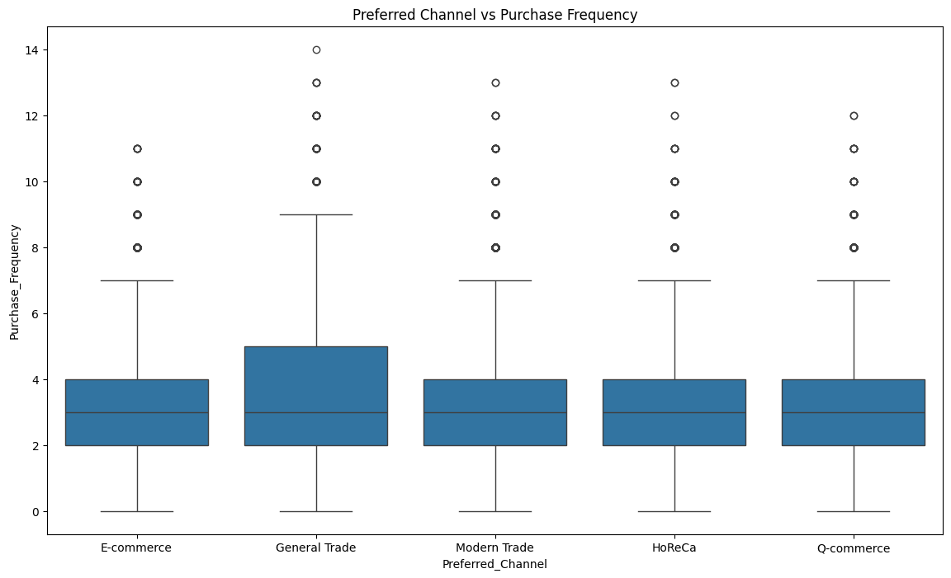

1. Also. We discovered that our consumer base is varied across 3 price range and price sensitivity doesn’t play a role while the purchasing of the product.

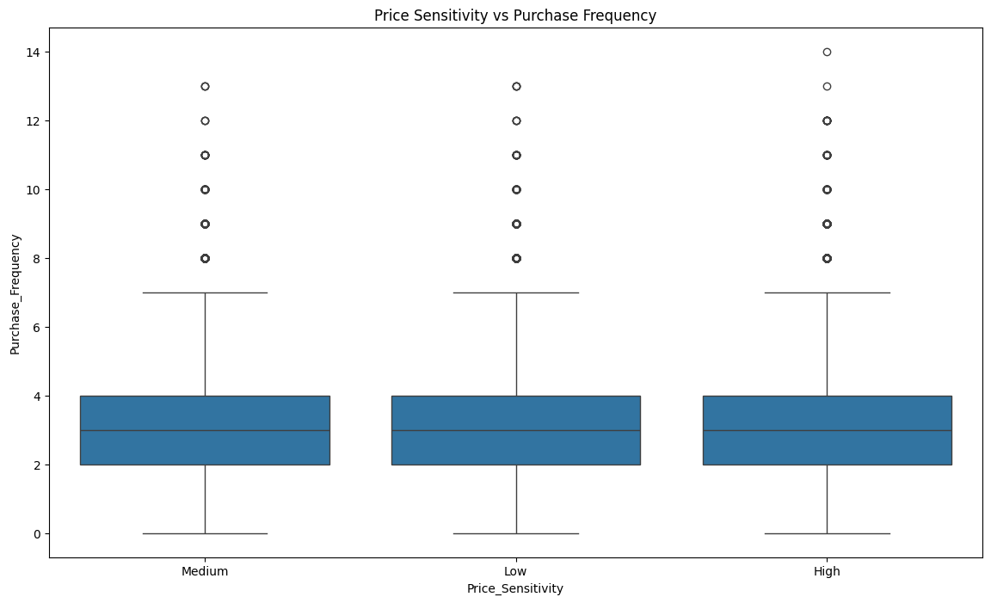

## Sales Trend (Bivariate and Multivariate Analysis)

1. I have compared Sales across various aspects based on the channel-wise distribution, product-wise distribution, city-wise distribution, etc.

### Channel-wise Sales Distribution

1. General Trade channel is the highest earning channel, while Q trade is the least.
2. Seasonal Trends: There are noticeable peaks in certain months (e.g., May 2023, April 2024, and June 2024), indicating possible seasonality or promotional events during those periods.

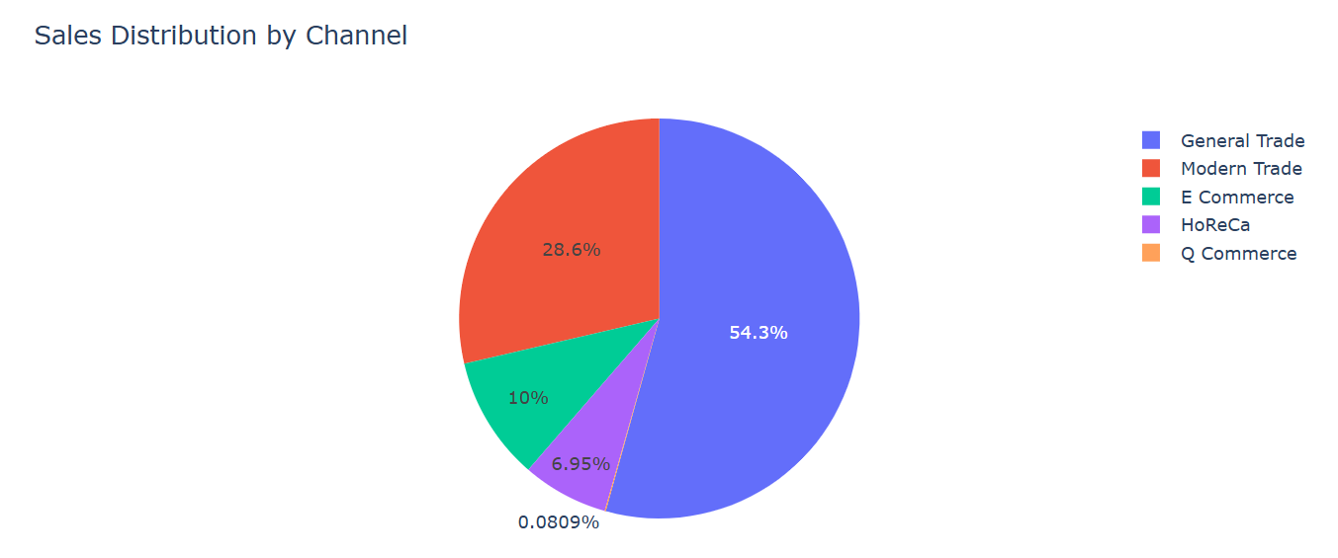

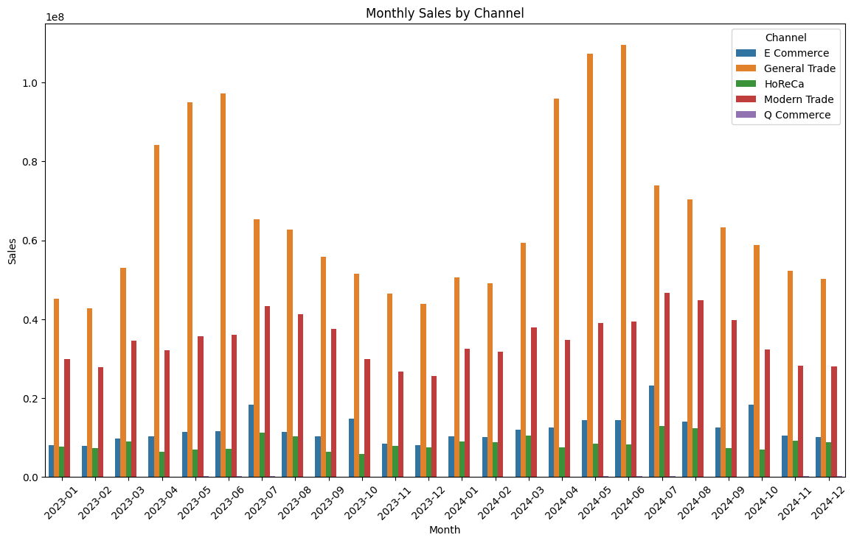

### City-wise Sales Distribution

1. All the city follows a specific trend, showing a seasonality trend. More sales during summare season.  
   a. Sales peak around April to June and May to July.  
   b. Sales decline from August to December, showing a seasonal dip.
2. Last 7 cities(Jammu, Patna, Kolkata, Bhopal, Jaipur, Ludhiana, Lucknow) show low market penetration with less sales or demand.

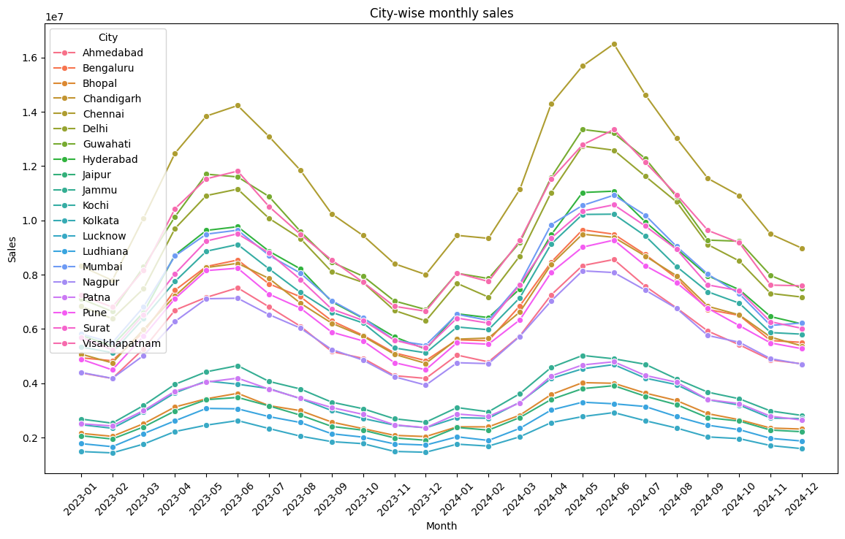

### Product-wise Sales Distribution

1. Our top selling product is "Minute Maid 250ml Pulpy Orange".
2. Summer spike pattern is visible, with sales rising between April to June and then gradually tapering off towards year-end.

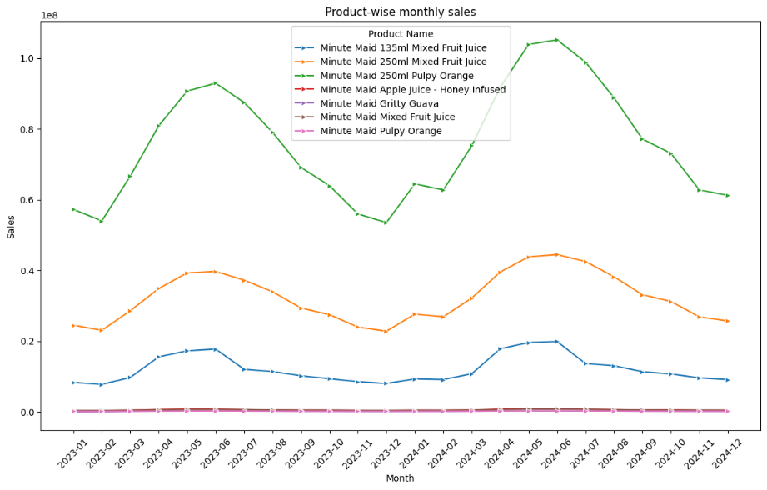

### Flavor-wise Sales Distribution

Orange flavor is leading the market, proving that "Pulpy Orange" is highest selling product.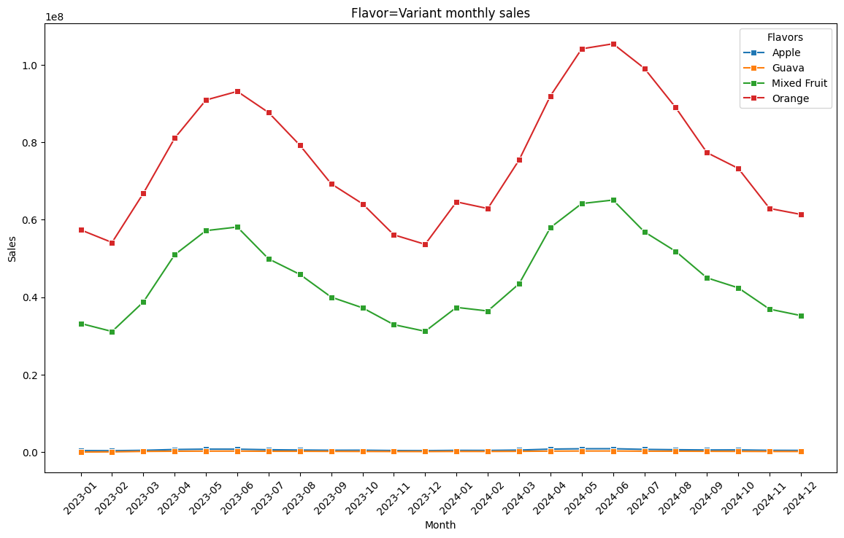

### Comparative Chart between Per Capita Income and Total Sales by City

1. Cities with more per capita income show relatively higher total sales, indicating a potential correlation between wealthier populations and spending power.
2. Nagpur and Ahmedabad have relatively decent per capita income but show a notable drop in total sales, which could indicate untapped market potential.

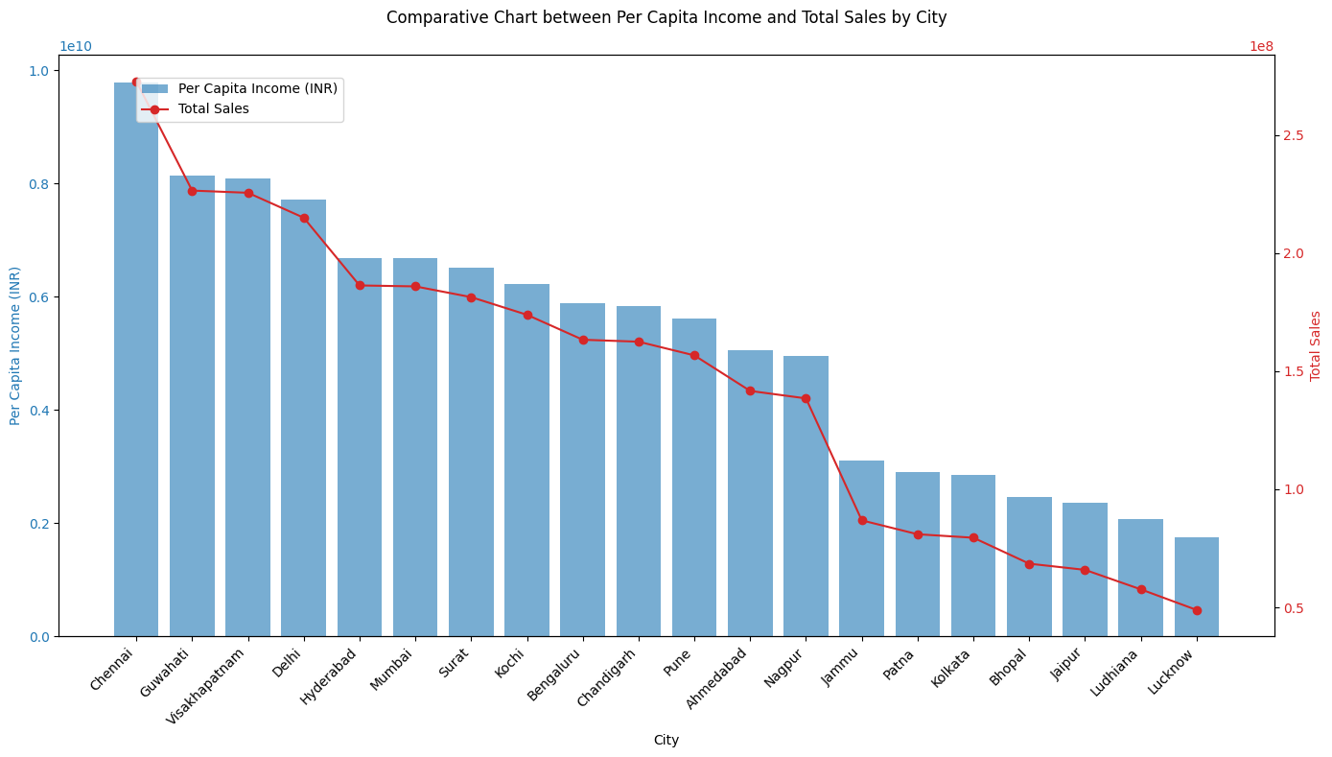

### Population density across cities vs Sales

Kolkata showing highest population density, have lowest sales, leading to market space that can be captured.

